Cubes and Dices

1. How many points will be on the face opposite to in face which contains 2 points?
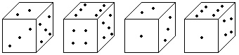
a. 1
b. 5
c. 4
d. 6

2. From the four positions of a dice given below, find the color which is opposite to yellow?
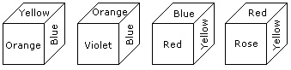
a. Violet
b. Red
c. Rose
d. Blue

3. Two positions of a dice are shown below. Which number will appear on the face opposite to the face with the number 5?
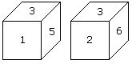
a. 2/6
b. 2
c. 6
d. 4

Directions for questions 4 to 6: Six dice with upper faces erased are as shows.
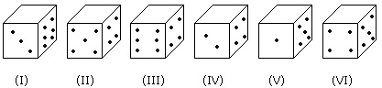
The sum of the numbers of dots on the opposite face is 7.

4. If even numbered dice have even number of dots on their top faces, then what would be the total number of dots on the top faces of their dice?
a. 12
b. 14
c. 18
d. 24

5. If the odd numbered dice have even number of dots on their top faces, then what would be the total number of dots on the top faces of their dice?
a. 8
b. 10
c. 12
d. 14

6. If dice (I),(II) and (III) have even number of dots on their bottom faces and the dice (IV),(V) and (VI) have odd number of dots on their top faces, then what would be the difference in the total number of top faces between there two sets?
a. 0
b. 2
c. 4
d. 6

Directions for questions 7 to 10: The following questions are based on the information given below:
1. There is a cuboid whose dimensions are 4 x 3 x 3 cm.
2. The opposite faces of dimensions 4 x 3 are coloured yellow.
3. The opposite faces of other dimensions 4 x 3 are coloured red.
4. The opposite faces of dimensions 3 x 3 are coloured green.
5. Now the cuboid is cut into small cubes of side 1 cm.

7. How many small cubes will have only two faces coloured?
a. 12
b. 24
c. 16
d. 14

8. How many small cubes have three faces coloured?
a. 24
b. 20
c. 16
d. 8

9. How many small cubes will have no face coloured?
a. 1
b. 2
c. 4
d. 8

10. How many small cubes will have only one face coloured?
a. 10
b. 12
c. 14
d. 18

Answer & Explanations

1. Option (d). Exp: In first two positions of dice one common face containing 5 is same. Therefore
according to rule no. (3) the face opposite to the face which contains 2 point, will contains 6 points.
2. Option (a). Exp: The colours adjacent to yellow are orange, blue, red and rose. Hence violet will be
opposite to yellow.
3. Option (c). Exp: According to the rule no. (3),common faces with number 3, are in same positions.
Hence the number of the opposite face to face with number 5 will be 6.
4. Option (c). Exp: Even numbered dice are: (II),(IV) and (VI)
No. of dots on the top face of (II) dice = 6
No. of dots on the top face of (IV) dice = 6
and No. of dots on the top face of (VI) dice = 6
Therefore Required total = 6 + 6 + 6 = 18
5. Option (a). Exp: Odd numbered dice are : (II),(III) and (V)
No. of dots on the top faces of these dice are 2, 2 and 4 respectively.
Required total = 2 + 2 + 4 = 8
6. Option(d). Exp: No. of faces on the top faces of the dice (I),(II) and (III) are 5, 1 and 5 respectively.
Therefore, Total of these numbers = 5 + 1 + 5 = 11
No. of dots on the top faces of the dice (IV),(V) and (VI) are 1, 3 and 1 respectively.
Therefore, Total of these numbers = 1 + 3 + 1 = 5
Required difference = 11 - 5 = 6.
7. Option (c). Exp:
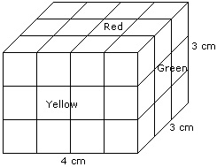
Number of small cubes having only two faces coloured = 6 from the front + 6 from the back + 2 from
the left + 2 from the right = 16.
8. Optin (d). Exp:
Such cubes are related to the corners of the cuboid and there are 8 corners.
Hence, the required number is 8.
9. Option (b). Exp:
Number of small cubes have no face coloured = (4 - 2) x (3 - 2) = 2 x 1 = 2.
10. Option (a). Exp:
Number of small cubes having only one face coloured = 2 x 2 + 2 x 2 + 2 x 1
= 4 +
4 + 2
= 10

